Faculty of Science and Technology
Department of Computer Science
GameLab: Mythos Grant
—
Jens Christian Valen Leynse
INF-3910 Computer Science seminar: GameLab - June 2025

Milestone 1: High concept

Working title
Mythos Grant

Group names and roles
Jens: Developer, designer

The «X»

When scholarly debates hit a dead end, rival historians armed with legendary sword relics settle the argument in a high-stakes tournament—where only one field of research wins the coveted grant money.

Time/Schedule
Milestone | Task | Description | Duration | Start date | End date
Design | Develop design doc | Game and technology defined | 3.5 weeks | 01.02.2025 | 25.02.2025
Production | Program core mechanics | Movement, combat actions, special abilities | 3 weeks | 26.02.2025 | 18.03.2025
Prototype | Create prototype | Playable game where characters can move, attack the opponent, and determine a winner or loser.
Production | Create assets | Characters, background, UI, level design, sound & music | 8 weeks | 19.03.2025 | 22.04.2025
Alpha | Alpha testing & bug fixing | Feature complete
Beta | Balancing | Content complete | 4 weeks | 23.04.2025 | 20.05.2025
Launch | Final polish |  | 2 weeks | 21.05.2025 | 04.06.2025

Game genre and theme
Mythos grant is a fast-paced, 1v1 fighting game that blends dynamic platforming with strategic sword combat. The theme is inspired by an academic setting mixed with mythological stories. The stages and music will reflect this theme, blending modern and ancient aesthetics. The soundtrack will combine traditional instruments with electronic beats.

Game Mechanics, player goal, features
Players control characters who can move, jump, and dash around the screen while wielding large (proportionally sized) swords to attack their opponent. Each player has a health bar; when it is depleted, they lose the game. The goal of each player is to deplete the opponent’s health before their own. The swords will be able to slash (rotation), stab (direct attack) and parry (timed swing or button push). Each sword user will also have a special ability that affects how they approach their opponent. The abilities are mostly statistical through buffs or debuffs. Each character will therefore have different attack, movement and defensive stats. Examples of abilities include slowing the opponent on a successful hit, extending the duration of a hitbox, and healing upon attacking an opponent. The game will feature local multiplayer, requiring players to either share a keyboard (using separate key bindings) or use an external controller.

Key technical elements
The game will be programmed in Godot v4.3, with art, sound, and music either AI-generated or sourced from online assets.

Art style
The game features a cartoonish art style. Characters have a distinctively limbless design, with their head, hands, and feet invisibly linked to their torso (inspired by Rayman). This design influences their movement and interactions with opponents' swords. Attire is inspired by the nationality of the sword each character uses. Stages—including backgrounds, walls, and platforms—are inspired by academic settings such as libraries, science labs, courtyards, cafeterias, PC labs, and auditoriums.

Story (World/Environment/Characters)
Players take control of characters armed with legendary sword relics, each imbued with unique abilities that reflect their historical significance.
Story: Historians reach an impasse over which ancient myth merits further research—and when scholarly debate falls short, there’s only one way to settle it. In a one-off, high-stakes tournament, rival historians armed with legendary sword relics duel for supremacy. The winner’s field of study secures the coveted grant money, ensuring their myth will be explored, and celebrated.
Environment: The arenas blend classical academia with mythic battlegrounds, ranging from ancient temples and historic cities to various rooms across a modern campus.
Character: Each character represents a different mythos, bringing their own research, pride, and unique sword-fighting techniques into battle.

Market positioning, target Platform, revenue and distribution model
Mythos Grant is positioned as a competitive 1v1 fighting game with fast, fluid movement inspired by Super Smash Bros. Ultimate, Super Smash Bros. Melee, and Celeste. It targets players who enjoy technical gameplay, precise movement, and strategic combat, offering a fresh twist by introducing mythological themes and unique interactions.

Platform: The game will initially be developed for PC (Windows) with local multiplayer support. Controller compatibility is a secondary priority but may be implemented to provide a familiar experience for fighting game enthusiasts.

Distribution: The plan is to release the game as a downloadable title on itch.io, with potential expansion to be determined.

Concept sketch

Milestone 2: Design

Design decisions
The game will be a "couch co-op" multiplayer game, allowing players to compete against each other on the same server or PC. While online multiplayer is a potential future feature, the primary focus is on local multiplayer to ensure optimal performance and minimal latency, which is crucial for the fast-paced gameplay.

Game Type:

Multiplayer: Primarily local ("couch co-op") with potential for online multiplayer in future updates.

Single-Player: Not a focus, but a training/ test mode could be added later.

Visual Style:

The game will be 2D or 2.5D, depending on the character models.

The art style will be low-poly, with animations created either through manual frame-by-frame animation or 3D rigging for 2D characters (2.5D).

Data Storage:

Data will be stored locally to minimize loading times and avoid lag spikes. Pre-loading assets will ensure smooth gameplay.

Platform:

Initially designed for PC, but with potential for console compatibility to broaden the player base.

User Interface (UI):

The UI will be minimalist, using simple image layering to maintain the game's aesthetic.

Features
The game's features are divided into must-have, should-have, and nice-to-have categories to prioritize development.
Core Gameplay Mechanics (Must-Have):

Movement:

Players can jump higher than the average platform height and dash in all 8 directions.

Dashing can transfer momentum when interacting with platforms or walls, adding depth to movement.

A single dash is available until the player lands or performs a wall jump.

There will be one button for both jump and dash.

Combat:

Players can swing or focus their sword.

The sword follows the player, either trailing behind or leading in front, depending on whether it's focused.

Sword swings gain power based on distance traveled but follow the shortest path to the target.

Parrying is possible by focusing the sword in front of the player. Successful parries stun the opponent, but parrying a swing causes the defender to lose to power.

Rock-Paper-Scissors Mechanics:

Stab beats Swing.

Parry beats Stab.

Swing beats Parry.

Special Abilities:

Each sword has a unique ability, such as:

Harpe: Slows the opponent's movement.

Tyrfing: Grants additional attack power but causes exhaustion afterward.

Nuada: Heals the user after multiple successful hits.

Zulfiqar: Performs a sweeping attack that can block enemy attacks.

Lævateinn: Confuses the opponent, randomizing their first three dashes.

Exploration and Progression (Should-Have):

Stages:

Each stage will have a unique background and platform setup.

The winner of each match influences the next stage, adding a dynamic element to gameplay.

Nice-to-have features include thematic elements (e.g., mythological references) and visual storytelling in the background.

Character Customization:

Players can earn in-game currency to unlock armor for their characters.

After 5 victories, a player's character becomes fully armored, symbolizing their dominance.

Accessibility and Difficulty (Must-Have):

The game's difficulty is player-driven, with no AI opponents or obstacles.

Character silhouettes will be distinct to ensure visibility, even for players with visual impairments.

Voice Lines (Nice-to-Have):

Characters will have voice lines when entering the stage, adding personality and immersion.

Example: A character might say,
“Let’s make history—by erasing yours.”
“I’d cite my sources, but you won’t live to read them.”
“Your thesis? Flawed. Your methods? Laughable. Your fate? Sealed.”
“This blade has seen centuries. You won’t last minutes.”
“They say “sword name” is unbreakable. Shame you’re not.”

Asset list
The game will require a variety of assets, including graphics, sound, and UI elements.
Graphics:

Character Models: Low-poly designs, either 2D or 2.5D.

Backgrounds: Unique environments for each stage.

Platforms and Walls: Customizable designs to match the stage themes.

UI Elements: Health bars, menus, and buttons.

Weapon Models: Unique designs for each sword.

Sound:

Background Music: Upbeat electronic music created using AI tools.

Sound Effects: Sword clashes, player damage, dashing, jumping, and stage transitions.

Voice Lines: Short phrases for character entrances and victories.

Other Assets:

Fonts: Easy-to-read, minimalist fonts.

Particle Effects: Sparks for sword clashes, dust for jumps and dashes.

Workflow:

Core Mechanics:

Default character, sword, stage, and platform models.

Multiplayer Integration:

Implement local multiplayer functionality

Immersion Mechanics:

Health UI, music, sound effects, and particle effects.

Additional Mechanics:

Menu screens, 8 sword models, 3 stages, and 8 wall designs.
.

Visual overflow
Scene Descriptions:

Main Menu: A simple, intuitive interface with options for Play, Controls, Settings, and Credits.
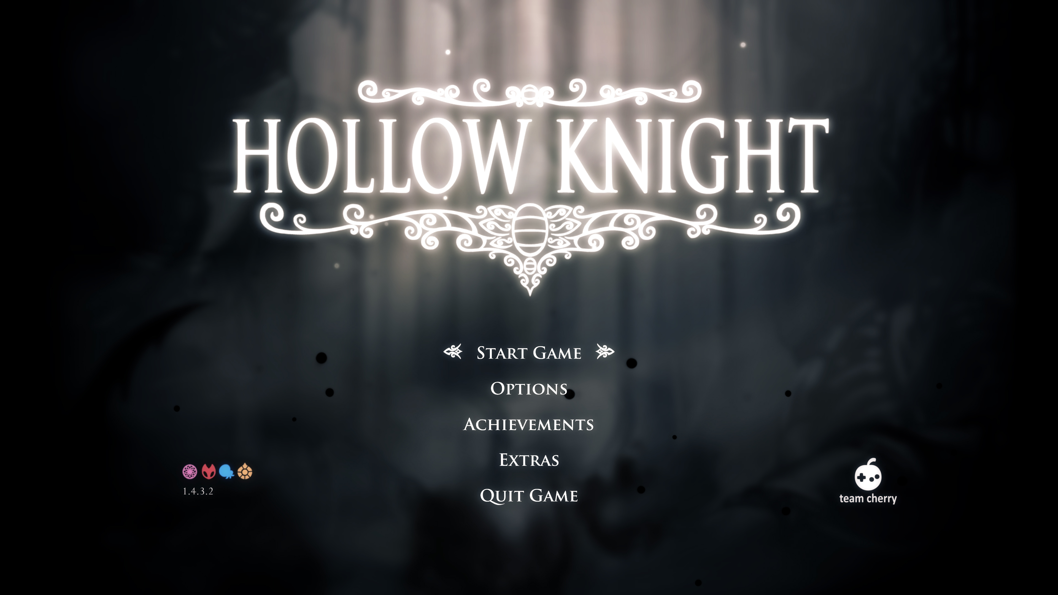
Like this only with
thematic elements corresponding to the myths featured in the game.

Gameplay: Fast-paced combat on dynamic stages with distinct themes.

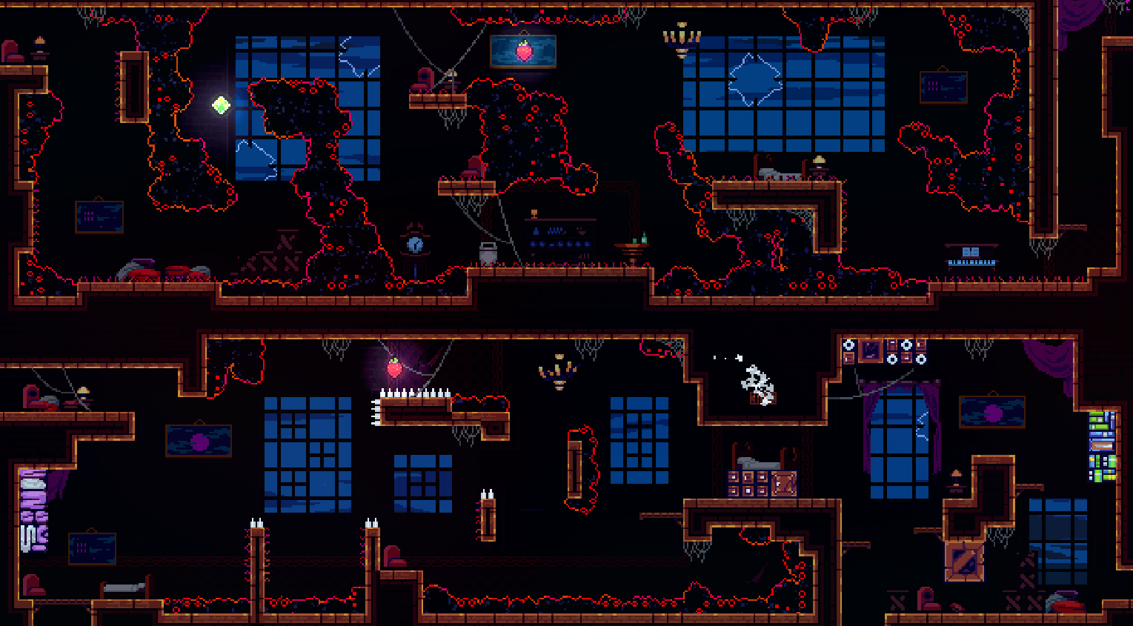
I want the platform layout to be inspired by Celeste's level design, where the foreground and background blend seamlessly to create a cohesive feel. However, the stages need to be much more open. I imagine some platforms and walls in the middle to break up the space and add more variation.

Victory Screen: A celebratory screen showcasing the winning player's character.
To be decided

Select Screen: Players choose their sword, stage, and music.
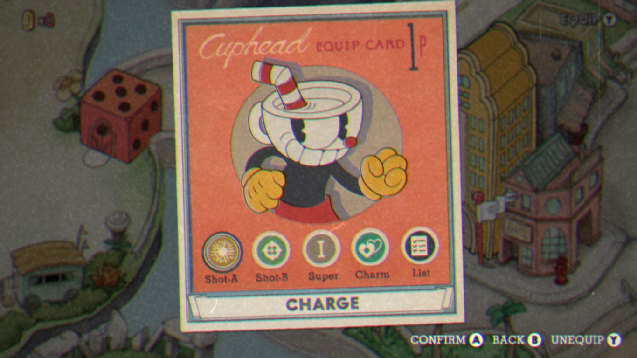
I want the character select screen to resemble this, but instead of characters, players will select swords (which correspond to characters). Both the swords and controls will be displayed on the sides, while common options like stage and music will be centered.

Control Screen: Customize controls for keyboard and controller.
To be decided

Settings: Adjust screen mode, music, and sound settings.
To be decided

User Flow:

Players start at the Main Menu.

They select Play and choose their characters and stage (music is set to default unless changed).

After the match, they return to the Main Menu or proceed to the next stage.

Art Style:

The low-poly aesthetic ensures a clean, modern look while keeping performance optimal.

Animations:

Character Movements: Smooth transitions for jumps, dashes, and attacks.

Environmental Effects: Subtle animations like moving clouds or flickering lights in the background.

Revenue plan
[How will you make money from the game?]
Monetization Strategies:

Self-Publishing: Release the game at a low cost and focus on marketing through social media and influencers.

Publisher Partnership: Pitch the game to a publisher for additional funding.

Post-Launch Content: Update with new stages, characters, or swords.

Pricing Model:

The game will be free at launch for alpha users to provide feedback, then increased to an adaptable price based on interest.

Marketing Plan:

Social media: Promote the game on platforms like Twitter, Instagram, and TikTok.

Influencers: Partner with gaming YouTubers and Twitch streamers.

Scope and time estimate
Development Phases:
Training
- Task: Learn new tools (e.g., Blender, Godot).
  - Duration: 2 weeks (integrated into Production phase).
  - Start Date: 26.02.2025.
  - End Date: 11.03.2025.

Asset Creation
- Characters and Swords:
  - Duration: 1 month (integrated into Production phase).
  - Start Date: 19.03.2025.
  - End Date: 18.04.2025.
- Stages and Backgrounds:
  - Duration: 1.5 months (integrated into Production phase).
  - Start Date: 19.03.2025.
  - End Date: 22.04.2025.
- UI and Sound:
  - Duration: 1 month (integrated into Production phase).
  - Start Date: 19.03.2025.
  - End Date: 22.04.2025.

Coding
- Core Mechanics:
  - Duration: 2 months (integrated into Production phase).
  - Start Date: 26.02.2025.
  - End Date: 22.04.2025.
- Additional Features:
  - Duration: 1.5 months (integrated into Production phase).
  - Start Date: 26.02.2025.
  - End Date: 22.04.2025.

Technical design
Game Engine:

Godot: Chosen for its flexibility, cross-platform support, and ease of use.

Software Tools:

Blender: For 3D modeling.

GIMP: For textures and UI design.

Audacity: For sound editing.

ComfyUI/Fugatto: For AI-generated assets.

Performance Optimization:

Reduce polygon counts for models.

Optimize code to minimize resource usage.

Risks
Technical Risks:

Performance bottlenecks on lower-end hardware.

Networking issues for online multiplayer (if added).

Schedule Risks:

Delays in asset creation or coding.

Budget Risks:

Unexpected costs for tools or assets.

Market Risks:

Competition from similar games.

Changing player preferences.

Mitigation Strategies:

Regular testing to catch issues early.

Flexible timelines to accommodate delays.

Contingency budget for unexpected expenses.

Milestone 3: Prototype

[Chapter 3-6 should combined be around 10-15 pages.]

Prototype implementation
[Describes the implementation that was done for the prototype. Scenes, flowcharts, ]
Core Mechanics Implemented
- Movement: Characters can move left/right, jump, and dash in 8 directions. Dashing transfers momentum when interacting with the ground
- Combat: Basic sword swings are implemented.
- Multiplayer: Local multiplayer functionality is implemented, allowing two players to share a keyboard or use a controller and a keyboard.

Assets Used
- Characters: Default low-poly models with limbless designs.
- Swords: Basic sword model for testing.
- Stage: A single test stage used from Smash ultimate’s stage design.
- UI: State and frame information for testing

Technical Implementation
- Engine: Godot v4.3 is used for development.
- Physics: Custom physics for movement, dashing, and sword interactions.
- Input Handling: Keyboard and controller inputs are mapped for multiplayer compatibility.

Figure 1. Example figure – Scene transition
Game setup
Main menu
About
Settings
Gameplay
Exit
.

Prototype goals
[What was the main goals of the prototype for you?]
The primary goals of the prototype were:
- Core Gameplay: Implement basic movement, combat, and multiplayer functionality.
- Technical Feasibility: Test the viability of the game’s mechanics in Godot.
- Player Interaction: Ensure smooth and responsive controls for local multiplayer.
- Art Style Validation: Confirm that the low-poly, limbless character design works in a 2D environment.
- A win condition: To be able to play an early rendition of my game with close to intended core mechanics.

Game state
[What is the current state of the game? What is still missing?]
Current State:
- The prototype is playable with basic movement, combat, and multiplayer functionality.
- Placeholder assets are used for swords, and stages.
- Core mechanics like dashing, jumping are functional.
- Sword interactions are in the works.
Missing Features:
- Combat Mechanics: Stabbing, parrying, and special abilities are not yet implemented.
- Stages: Only one test stage exists; additional stages with unique themes and platform layouts are needed.
- UI/UX: Menus and victory screens with thematic elements.
- Sound and Music: No sound effects or background music are included.
- Variable Tweaks: Balancing movement speed, dash distance, and attack power is pending.

What did I learn
Technical Insights:
  - Godot’s physics engine is well-suited for 2D platforming and combat mechanics.
  - Implementing multiplayer functionality locally is straightforward but requires careful input mapping.
Design Challenges:
  - Balancing movement and combat mechanics is crucial for maintaining fast-paced gameplay.
  - Pixel art requires creative animation solutions with time consuming but rewarding results.
Next Steps:
  - Focus on implementing stabbing, parrying, and special abilities to complete the combat system.
  - Add more stages with unique themes and platform layouts.
  - Create the UI/UX and integrate sound effects and music.

